1.(a)

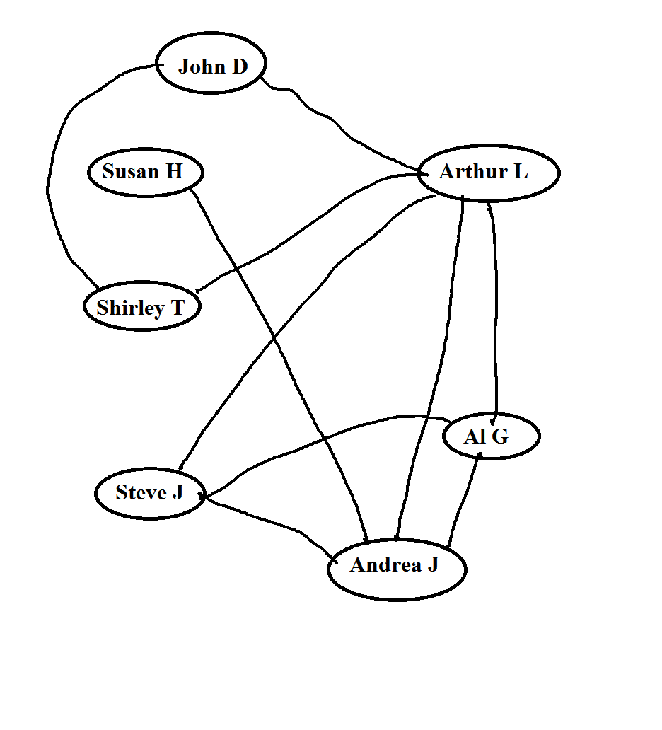

1.(b)

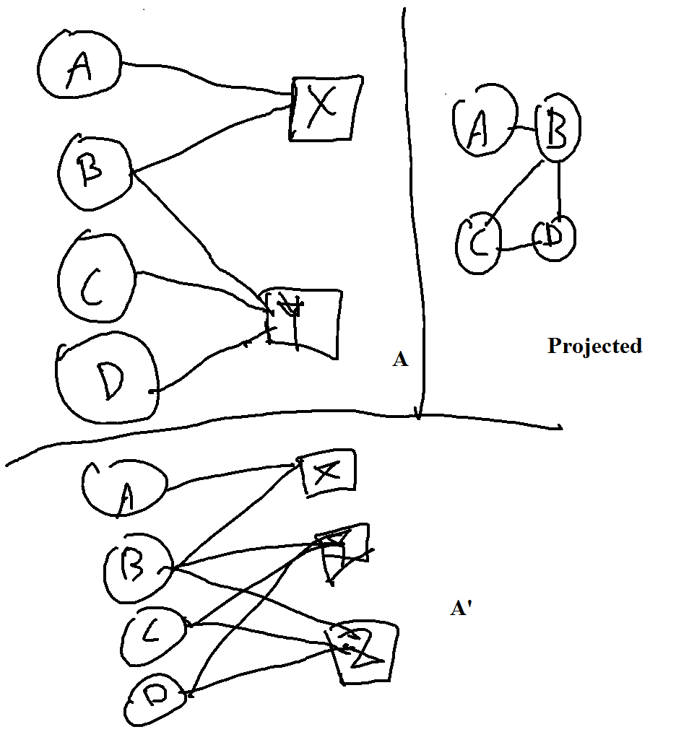

2.

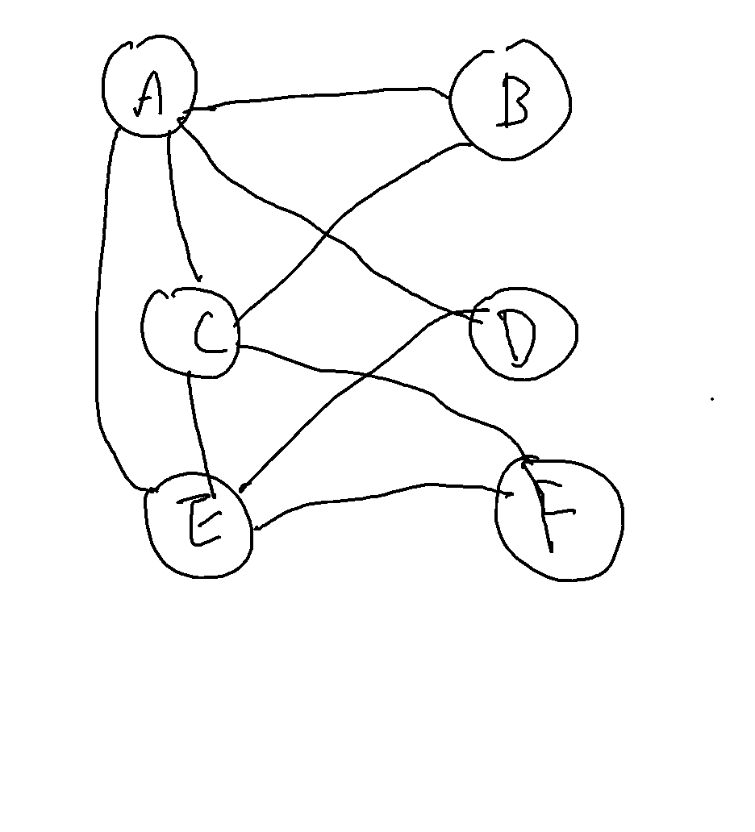

Every edge of the triangle ACE represents a different forci, whereas the edges of other triangles represents the same forci that connects the nodes

3.a

P=7/12, Q=5/12, C=3/16

2PQ=0.486111>C=0.1875

Thus there is homophily

3.b

Add x edges

(3+x)/(16+x)=(7/12)*(5/12)*2

X=9.29, x=10

New C= 13/26 = 0.5, C>2PQ

Thus no longer there is homophily

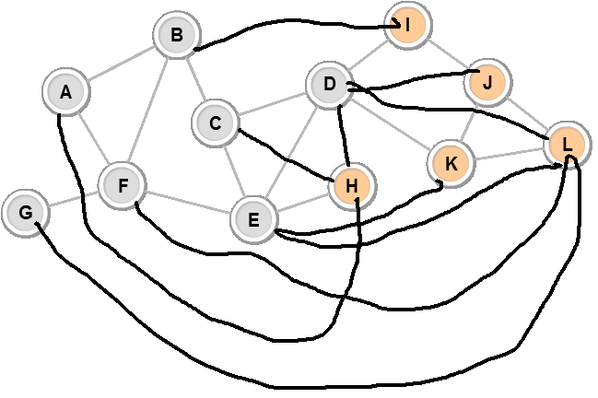

3.c.

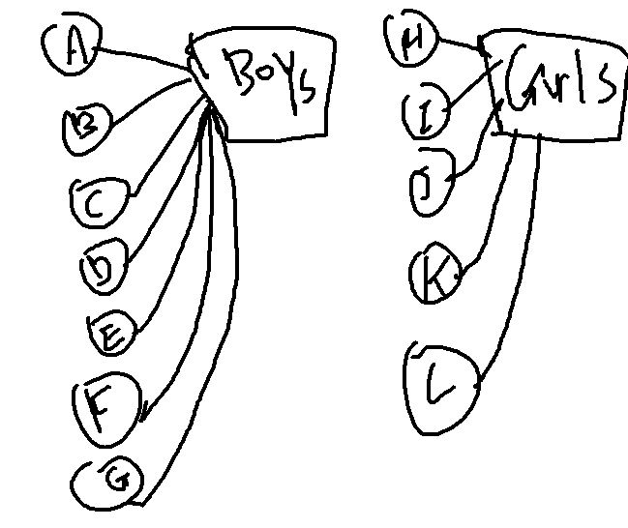

4.

|  |  |  |  |  |  |  |
| --- | --- | --- | --- | --- | --- | --- |
| # | N1 | N2 | Triadic | Group/Focal | Membership | None |
| 1 | BSI | D |  |  |  | X |
| 2 | CS | B |  |  |  | X |
| 3 | C | D |  |  |  | X |
| 4 | BSI | C |  |  | X |  |
| 5 | D | E |  |  |  | X |
| 6 | CS | E |  |  |  | X |
| 7 | C | E | X |  |  |  |
| 8 | CS | A |  |  |  | X |
| 9 | A | B |  | X |  |  |
| 10 | B | C |  |  |  | X |
| 11 | B | E |  | X |  |  |

5.

Social Influence

Because as time program, more person are connected to BSI/CS program though their known friends, instead of finding new friends after joining the same program. Thus it is clear that joining any one of the affiliation group is the result of having established relationship with other individuals

6.

Graph has 62 nodes and 159 edges

Graph has 1 connected components

Graph's average shortest path length is 3.3569539925965097

Network has diameter of 8

The node is called Number1

Avg. clustering coefficient for the network is 0.2589582460550202

Transitivity of the graph is 0.3087757313109426

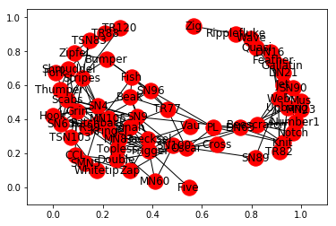

Yes, there seems to be local bridges